

|  |
| --- |
| Nomination Guidelines |
|  |

These guidelines outline the eligibility, terms and conditions, and categories for the 2018 Premier’s Volunteer Champions Awards. Please read these guidelines, and ensure that you understand and agree to the terms and conditions prior to participating in the 2018 Premier’s Volunteer Champions Awards.

Contents

About the Awards 2

Key stages and dates 2

Information and support 2

Terms and conditions 3

Eligibility 3

Nomination process 3

Judging and selection 3

Awards and recognition 4

Nominator’s consent 4

Nominee’s consent 5

Privacy statement 5

Privacy policy 5

Liability 5

Award categories 6

Victorian Premier’s Volunteer of the Year, Dame Elisabeth Murdoch Award 6

Leadership Award 6

Impact Award 6

Service Award 6

Teamwork Award 6

How to nominate 7

Create an account 7

Logging in 8

Individual volunteers 9

Teams 10

Create nominations 11

# About the Awards

**The Premier’s Volunteer Champions Awards acknowledge and celebrate the extraordinary contributions of all volunteers in Victoria.**

Across all ages and from all walks of life, volunteers provide a wide range of services, activities and support to Victorian people, communities and causes.

Volunteers respond to emergencies. They work with the vulnerable and the disadvantaged, reducing social isolation and improving health and wellbeing. Volunteers teach, mentor and inspire; or represent their communities. They run clubs, groups and events, or fundraise and support causes.

Most significantly, volunteers sacrifice their own time and resources. They are the heart and soul of Victoria and without them, many groups and organisations simply would not exist.

To highlight the significant number of volunteers, and the variety and impact of volunteering effort across the state, up to 60 volunteers will be formally recognised across four categories.

The *Premier’s Volunteer of the Year, Dame Elisabeth Murdoch Award*, will be selected from Award recipients across all categories.

# Key stages and dates

|  |  |
| --- | --- |
| **Nomination period** (April-May) | Nominations open 12.30pm, 19 April 2018 |
| Nominations close 5.00pm, 28 May 2018 |
| **Assessment and selection** (June-July) | Judging panel assesses nominations |
| Shortlisted nominees accept Terms and Conditions, and complete National Police Check Consent Form if applicable |
| **Announcement of recipients** (July-August) | Award Recipients notified |
| Shortlist for *Premier’s Volunteer of the Year, Dame Elisabeth Murdoch Award* notified |
| Recipient of the *Premier’s Volunteer of the Year, Dame Elisabeth Murdoch Award* announced at Award Ceremony |
| **Awards ceremony** | September 2018 |

# Information and support

Phone: 03 9096 7302 or 03 9096 1183

Email: [premiersvolunteerawards@dhhs.vic.gov.au](mailto:premiersvolunteerawards@dhhs.vic.gov.au)

Website: [www.volunteer.vic.gov.au/awards](http://www.volunteer.vic.gov.au/awards)

# Terms and conditions

1. A person who nominates (nominator) a person who is a volunteer or a team of volunteers (nominee) for the 2018 Premier’s Volunteer Champions Awards (Awards) and submits a nomination is deemed to have accepted these terms.
2. The State of Victoria acting through the Department of Health and Human Services (Department) is the promoter of the Awards.

## Eligibility

1. Nominee(s) must be living Australian residents (temporary or permanent) and currently residing in Victoria who, during the period 13 July 2017 to 28 May 2018 (inclusive), have undertaken, or are currently undertaking, voluntary work or activities in Victoria.
2. The nominee’s work or activity must satisfy:
   1. Volunteering Australia’s definition of volunteering, being “time willingly given for the common good and without financial gain” (see Volunteering Australia’s website, currently http://www.volunteeringaustralia.org/policy-and-best-practise/definition-of-volunteering/); and
   2. the criteria of the selected Award category.
3. A person cannot nominate themselves, whether in an individual capacity or as a member of a team.
4. Members of the judging panel, employees and contractors of the Department who are directly involved in conducting the Awards as well as their immediate families, are ineligible to be a nominator or a nominee.

## Nomination process

1. Completed nominations must be received after 12.30pm Thursday 19 April and before 5.00pm Monday 28 May 2018. Nominations received outside these times will not be considered for the Awards and no responsibility will be accepted by the Department for early, lost, late, incomplete or incorrectly submitted nominations.
2. A separate online nomination form must be completed for each nominee (or each nominated team). A nominator may only submit one entry per nominee.
3. All nominations and materials submitted to the Department in connection with the Awards will become the property of the Department and will not be returned.

## Judging and selection

1. The Department reserves the right to verify the validity of nominations, allocate nominations into an alternative category and disqualify any nomination which, in the opinion of the Department, can be considered objectionable, potentially insulting or inflammatory or generally damaging to the goodwill or reputation of the Awards, the Department and/or the Premier of Victoria, or any nomination that is not compliant with these Terms and Conditions.
2. The Department may request further information or clarification from the nominator or nominee(s).
3. A judging panel will consider all eligible nominations and rate each against the description for the selected Award category. Nominations with the highest combined scores will be shortlisted.
4. Nominees (including each member of a team) who are shortlisted will be required to:
   1. confirm their acceptance of these Terms and Conditions by following the instructions set out in the email notification; and
   2. if over 18 years of age, submit a completed National Police Check Consent Form with associated proof of identifying documents to the Department. The form outlines the requirements for obtaining a National Police Check and providing consent for such check to be conducted.
5. In the event that a nominee does not accept the Terms and Conditions or fails to submit a completed National Police Check Consent Form with proof of identity, the nominee will be removed from the shortlist.
6. Award recipients will be selected from shortlisted nominees who have, if required, undertaken a National Police Check. Consideration will be made as to the currency and seriousness of any offence(s), any known mitigating circumstances and the nominee’s subsequent contribution to Victoria.
7. The Department reserves the right to disqualify a shortlisted nominee in the event that the results of their police check are deemed unsatisfactory by the Department, with no right of review.
8. A judging panel will shortlist Award recipients for the Premier’s Volunteer of the Year, Dame Elisabeth Murdoch Award. The Premier of Victoria (or the Premier’s appointed representative) will select the recipient of the Dame Elisabeth Murdoch Award from this shortlist.
9. The Premier of Victoria (or the Premier’s representative) and the Department’s decisions on all matters pertaining to the Awards are final and no correspondence or discussion will be entered into.

## Awards and recognition

1. Eligible nominees who are not selected for an Award will receive a letter of appreciation.
2. Each Award recipient, and up to three guests, will be invited to attend the Awards ceremony to be presented with a certificate and badge of recognition. Award recipients under 18 years of age must be accompanied by a parent or legal guardian.
3. Nominators of Award recipients, and one guest, will also be invited to attend the Awards ceremony.
4. The recipient of the Premier’s Volunteer of the Year, Dame Elisabeth Murdoch Award will be announced at the Awards ceremony, and will receive a trophy and a $10,000 donation for a not-for-profit organisation of their choice. The chosen not-for-profit organisation must have operations in Victoria. The donation cannot be split across multiple organisations.
5. All travel costs associated with the nominator and Award recipient (and their guests, if applicable) attending the Awards ceremony and other ancillary costs are the responsibility of the nominator and Award recipient (and their guests, if applicable).

## Nominator’s consent

1. By submitting a nomination, including personal information provided as part of that nomination, each nominator confirms that he or she consents, and has the consent of any person whose personal information is contained in a nomination, including but not limited to the nominee(s) (or if under the age of 18, the nominee’s parent or legal guardian), to provide that information to the Department, and for the Department to disclose that personal information to other parties including, but not limited to, judges, the Premier’s Office and the Department of Premier and Cabinet, for the purposes of conducting the Awards.
2. Each nominator consents to the Department using the nominator’s statements, name, likeness, image, voice and/or participation in the Awards (including photograph, film and/or recording of the same) in any media for an unlimited period of time without further notification, remuneration or compensation for the purpose of promoting, publicising or marketing the Awards (including any outcome).

If the nominator does not agree, the nominator must not provide their personal information or the personal information of anyone else and may be unable to submit a nomination for the Awards.

## Nominee’s consent

1. By accepting their nomination, the nominee(s) (or if under the age of 18, the nominee’s parent or legal guardian) consents to:
   1. the Department using their nomination statements, name, likeness, image, voice and/or participation in the Awards (including photograph, film and/or recording of the same) in any media for an unlimited period of time without further notification, remuneration or compensation for the purpose of promoting, publicising or marketing the Awards (including any outcome); and
   2. the Department using their personal information, and for the Department to disclose their personal information to other parties including, but not limited to, judges, the Premier’s Office and the Department of Premier and Cabinet, for the purposes of conducting the Awards.

If the nominee does not agree, the nominee must not accept their nomination and will be ineligible for an Award.

1. By submitting a National Police Check Consent Form, the nominee will be consenting to the Department, the Premier’s Office and the Department of Premier and Cabinet, being provided with the results of their National Police Check for the purposes of conducting the Awards.

## Privacy statement

1. Consistent with Victorian Government policy and legislation, the Department endorses fair information handling practices. Personal, health and sensitive information supplied will be used by the Department, the judging panel, the Department of Premier & Cabinet, the Premier’s Office and the Award ceremony venue for the purposes of considering nominations, selecting Award recipients and providing the Award Ceremony. Information will not be disclosed or used for any other purpose without the express consent of the person to whom the information relates, unless otherwise required or permitted by law.

## Privacy policy

1. The Department’s Privacy Policy sets out information about how the nominator or nominee(s) may access and seek correction of their personal information or complain about a breach of their privacy, and how the Department will deal with that complaint. The Department's Privacy Policy is located at <https://dhhs.vic.gov.au/publications/privacy-policy>

## Liability

1. It is intended and agreed that the conduct of the Awards shall not give rise to any legal obligations or duties, valid or enforceable in any way against the Department or the Premier of Victoria.

# Award categories

## Victorian Premier’s Volunteer of the Year, Dame Elisabeth Murdoch Award

The prestigious Dame Elisabeth Murdoch Award will be selected from Award recipients in the following four categories to honour their significant contribution and outstanding commitment to Victoria.

*This Award is not open for direct nominations.*

## Leadership Award

The Leadership Award recognises people who have shown exceptional influence or leadership in support of a community, people, group, organisation or cause in Victoria. Nominees will be inspiring people who may have built effective networks, empowered others or coordinated effort, or they may have motivated, encouraged, guided or supported others.

*This award is open to individuals of all ages, locations and work type.*

## Impact Award

The Impact Award recognises people who have made a significant and positive impact on a community, people, group, organisation or cause in Victoria. Nominees may be innovators and pioneers, or may be enthusiastic, creative or hardworking people, whose contribution is effective and expected to have a lasting effect.

*This award is open to individuals of all ages, locations and work type.*

## Service Award

The Service Award pays tribute to community minded people who have made persistent and selfless contributions to a community, people, group, organisation or cause in Victoria. Nominees will be passionate and generous role models, whose reliable and dedicated commitment is an inspiration to those around them.

*This award is open to individuals of all ages, locations and work type.*

## Teamwork Award

The Teamwork Award celebrates the power of collaboration to achieve great outcomes for a community, people, group, organisation or cause in Victoria. Nominees in this category will be teams of up to 10 people who have worked together on a common project, demonstrating that effective or consistent group effort can achieve greater outcomes.

*This award is open to teams of all ages, locations and work type.*

*Members of the team must work, or have worked, directly with each other on a specific project, and can be from multiple organisations or groups.*

*This category does not intend to recognise ongoing programs or day-to-day activities of a group or organisation, rather the focus is on a group of people who have successfully worked together to achieve a common goal or outcome.*

# How to nominate

Nominations must be submitted through the nomination website at: <https://premiersvolunteerawards.awardsplatform.com>

## Create an account

1. Go to: <https://premiersvolunteerawards.awardsplatform.com>
2. Enter your Name, Email and Password in the fields under ‘Register’
3. Click the ‘Register’ button

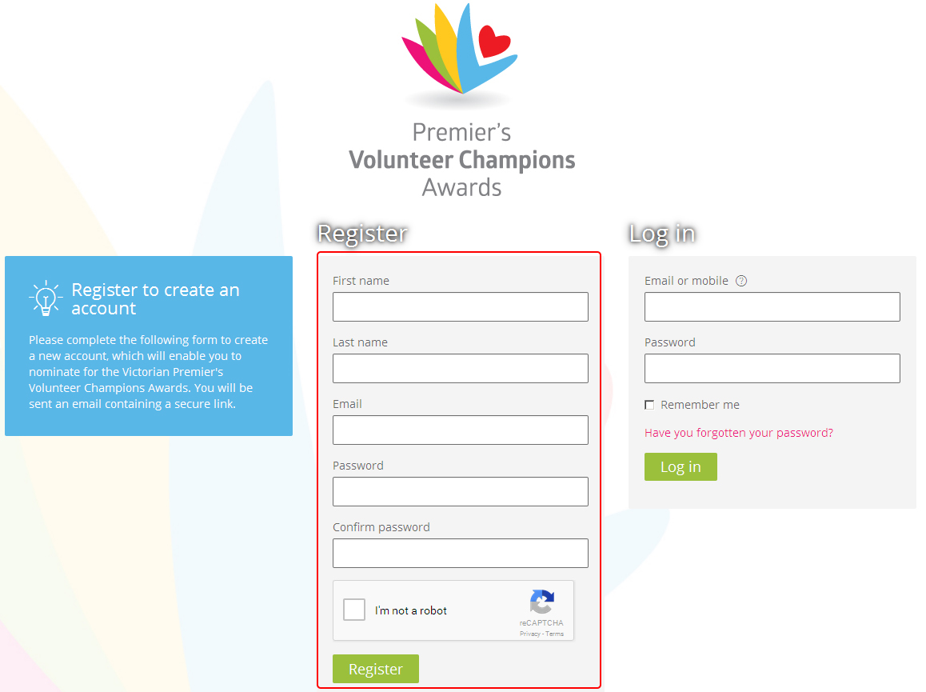

*You will be taken to a second screen for Additional Details.*

1. Enter your Title, Postal Address and Phone Number.
2. Click the ‘Complete profile’ button

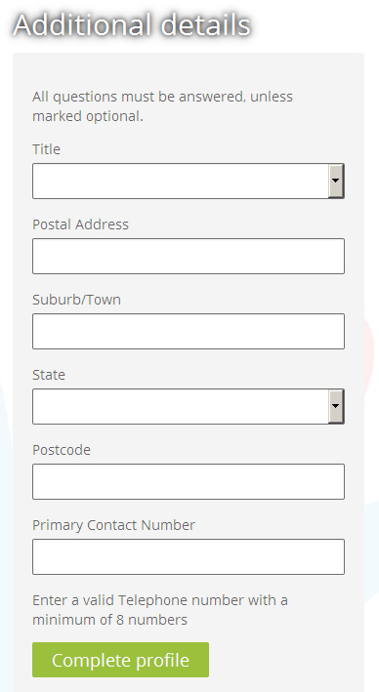

1. Check your email for an ‘Account confirmation’ email
2. Click the Verification Link to confirm your registration

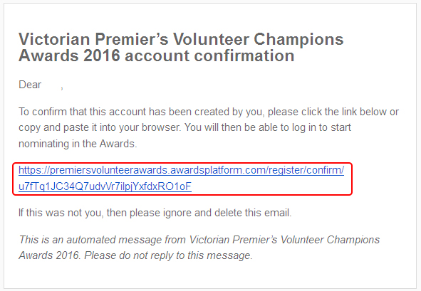

## Logging in

1. Go to: <https://premiersvolunteerawards.awardsplatform.com>
2. Enter your Email address and Password in the fields under ‘Log in’
3. Click the ‘Log in’ button

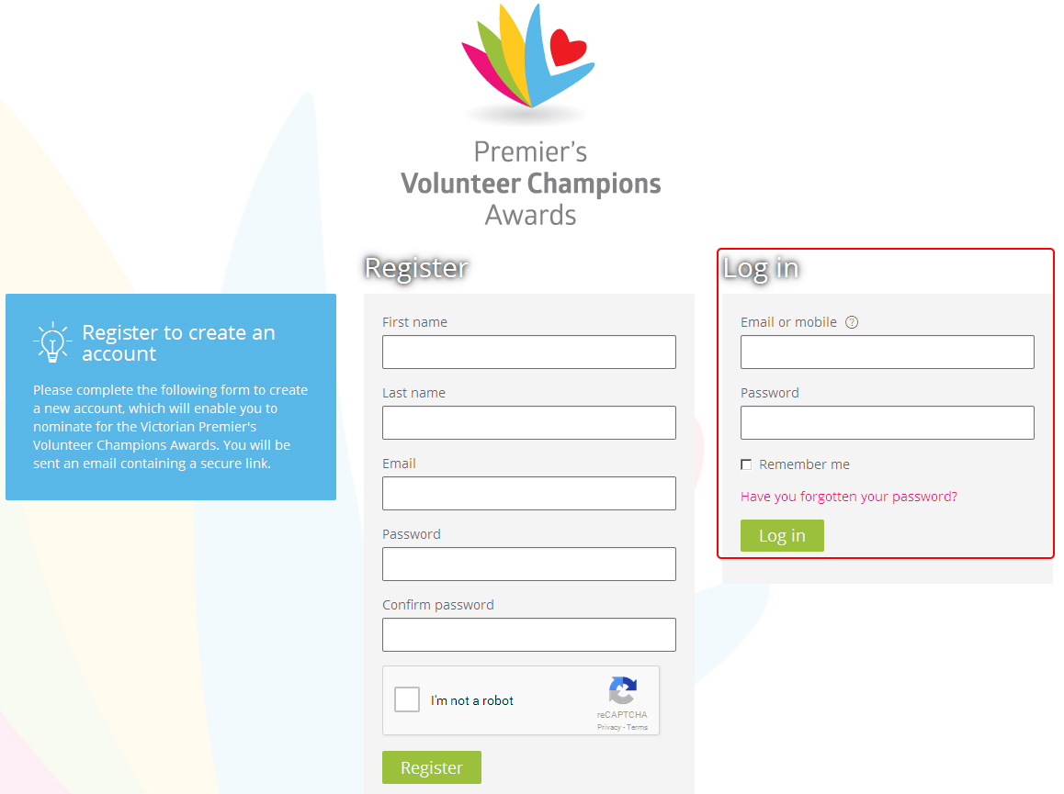

## Individual volunteers

Individual volunteers can be submitted in the following categories:

* Leadership
* Impact
* Service

### Information required

To submit a nomination you will need the following information:

* Personal details for the volunteer, including:
  + Name
  + Age range
  + Contact details: email, phone and postal address
  + Current organisation, role and length of service
* Nomination statements:
  + Summary (40 words) – Tell us why you are nominating the volunteer
  + Achievement & outcomes (150 words) – Describe the major achievements, benefits or outcomes of their work.
  + Skills & qualities (150 words) – Describe how this contribution was/is made. You can include personal skills, attributes and qualities, and any other comments on how they go about their work.
  + Commitment & effort (40 words) – Describe the amount of time, effort and dedication they have spent on their activities.

## Teams

Volunteer teams can be submitted in the Teamwork category only.

### Information required

To submit a nomination, you will need the following information:

* Information about the team / project, including:
  + Where the project is located
  + Name of the team’s project / activity
  + Photo of the team (please include only people being nominated)
* Personal details for each team member, including:
  + Name
  + Age range
  + Role
  + Contact details: email and phone
* Nomination statements
  + Summary (40 words) – Tell us why you are nominating the team
  + Achievement & outcomes (150 words) – Describe the major achievements, benefits or outcomes of their work.
  + Skills & qualities (150 words) – Describe how this contribution was/is made. You can include personal skills, attributes and qualities, and any other comments on how they go about their work.
  + Commitment & effort (40 words) – Describe the amount of time, effort and dedication they have spent on their activities.

## Create nominations

1. Click the ‘Start entry’ button

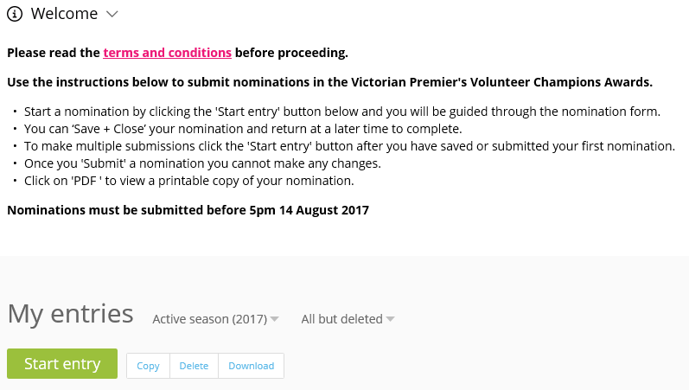

1. Select a category
2. Enter a name for your nomination
3. Tick the checkbox to accept the Terms and Conditions
4. Click the ‘Save + next’ button

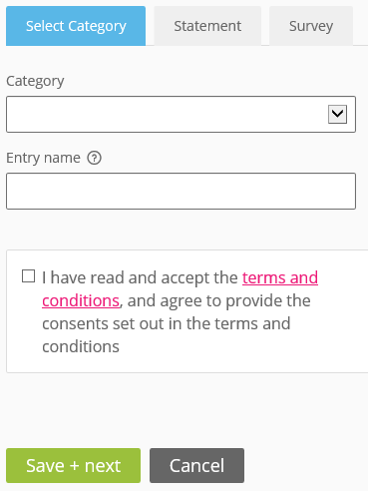

### Enter nomination details

1. Complete all mandatory fields on each tab
2. Click the ‘Save + next’ button to proceed to the next tab

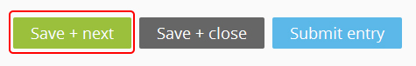

### Submit entry

1. Check that all information is correct

*Note: once you submit a nomination, you cannot make any further changes*

1. Click the ‘Submit entry’ button.



### Hints

**Save your entry and return later**

1. Click the ‘Save + close’ button



1. To return, select the nomination from your ‘My entries’ list

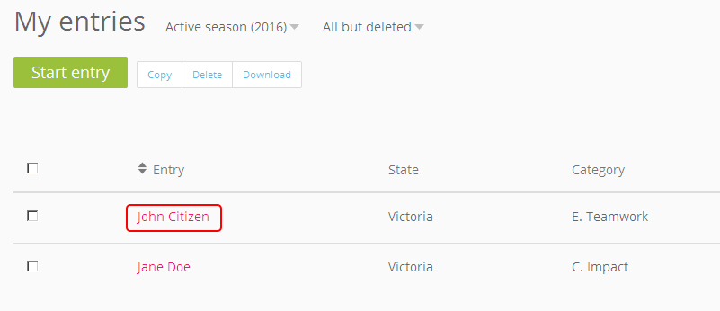

**Download a PDF of your nomination**

1. Go to your ‘My entries’ list
2. Click the ‘PDF’ icon next to your nomination

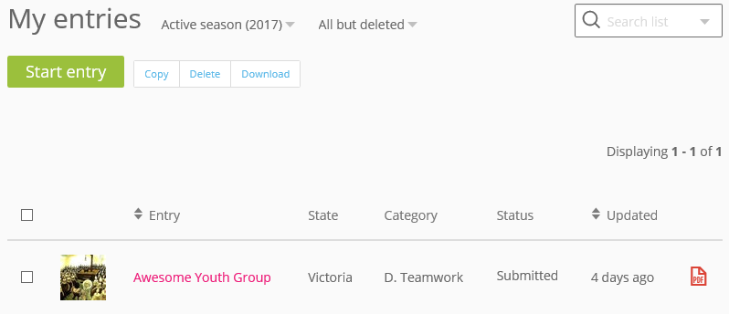

|  |
| --- |
| To receive this publication in an accessible format phone 03 9096 1183, using the National Relay Service 13 36 77 if required, or email [Premier’s Volunteer Awards](mailto:premiersvolunteerawards@dhhs.vic.gov.au) <premiersvolunteerawards@dhhs.vic.gov.au>  Authorised and published by the Victorian Government, 1 Treasury Place, Melbourne.  © State of Victoria, Australia, Department of Health and Human Services April 2018.  Available at [Premier’s Volunteer Champions Awards](http://www.volunteer.vic.gov.au/awards) <www.volunteer.vic.gov.au/awards> |